National Virtual Conference on “Reforms in Curriculum, Pedagogy in the Light of NEP-2020” 25th June 2022
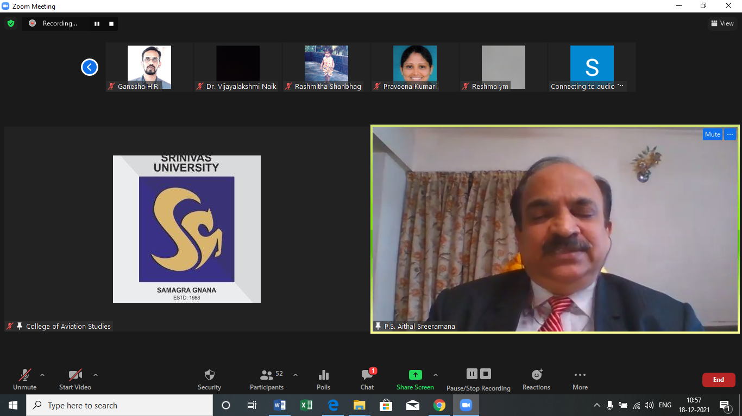

College of Education Srinivas University will be Organising a National virtual conference through virtual platform on “Reforms in Curriculum, Pedagogy in the Light of NEP-2020” on Saturday 25 June 2022 at 10:00 a.m. Dr. Vijay Kumar R, Former Regional Director (NRC & ERC) & Deputy Secretary, NCTE, New Delhi & Associate Professor, School of Education, Pondicherry University, Pondicherry will be delivered the key note address. The Session was chaired by Dr. Pradeep M.D., Associate Professor, Institute of Social Science & Humanities, Srinivas University, Mangalore. This conference is mainly intended for students, student teachers, educators, lecturers, research scholars and other invited for participation to present their views research findings on the theme. 28 papers were published as conference proceedings with ISBN and selected paper will be published in peer-reviewed journals with ISSN.
*********************

